Chapter 3, Problem 2.

For the circuit in Fig. 3.51, obtain v₁ and v₂.

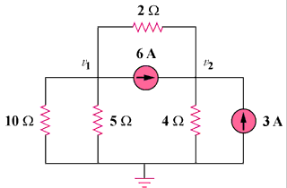

Figure 3.51
For Prob. 3.2.

